22q11 syndromes All-Party Parliamentary Group
Inaugural Meeting
Wednesday 13th September 2017 4-5pm
Committee Room 16, House of Commons

Minutes

Present:
Jack Lopresti MP, David Duguid MP, Heidi Allen MP, Melanie Onn MP, Angus MacNeil MP

Secretariat (Max Appeal): Julie Wootton, Paul Wootton, Claire Hennessey, Carla Attwood, Julie Jones and Mark Tripp

1. Welcome and Introduction

Jack Lopresti MP opened the meeting and welcomed new members to the APPG. He confirmed that the required number of sponsoring MPs had been achieved so that this important All-party Parliamentary Group can be registered.

2. Apologies

Julian Sturdy MP, Daniel Kawczynsi MP, Shailesh Vera MP, Lindsay Hoyle MP

3. Election of officers

Jack Lopresti MP then announced his resignation as Chairman of the APPG. He proposed David Duguid MP as the new Chairman and Heidi Allen seconded this proposal.

Other officers for the APPG were elected: Heidi Allen – Secretary, Jack Lopresti – Vice Chair, Melanie Onn – Vice Chair

Julie Jones was noted as minute taker and Julie Wootton confirmed that Max Appeal would act as secretariat to the APPG.

4. APPG Aims for this Parliament

To build upon the previous report submitted at the final AGM of the 22q11 syndromes APPG during the previous Parliament term:

- Diagnostic testing - Pre-natal diagnosis is important. There are new advances in non-invasive tests using maternal blood samples for full array DNA analysis. Detailed scans at 20 weeks only identify around 30% of congenital cardiac defects. Many USA States already carry out tests for immunodeficiencies and oxygen saturations at birth which can identify some of those with 22q11 syndromes.
- Once diagnosed a ‘One Stop Shop’ for patients (liver, heart, immune testing, SALT etc) provides optimum care.
- Mental Health Issues for young people and adults with 22q11 syndromes is very high. It is the single commonest known cause of schizophrenia but awareness in appropriate care providers is low. 25% of those with 22q11 will develop psychosis.
- Benefits – 22q11 syndromes does not appear in the handbook for those assessing DWP/DLA applications and this should be addressed.
- Education – it is known that appropriate help/support in education is very limited and using already known resources is very much needed. The IQ of a 22q11 person will have at least 30% lower IQ than their unaffected parents. There are significant behaviour and personality traits that must be accommodated.

The awareness of 22q11 syndromes was discussed. It is estimated that as many as 128,000 people in the UK are living with this condition but only there are only just over 3,000 with a formal diagnosis.

It was also noted that Max Appeal is the only charity registered with the Charity Commission for 22q11DS. There is a registered group in Northern Ireland (22q11NI). Working with organisations and groups that have common issues and objectives was identified as a good target.

6. Any other business

The APPG registration form was signed by the new Chairman, David Duguid MP. The secretariat will perform administration duties to effect registration. Photographs and statements to be issued to appropriate press/media by the secretariat.

The secretariat will source clinicians and experts to attend meetings and inform the APPG.

7. DNM

TBC

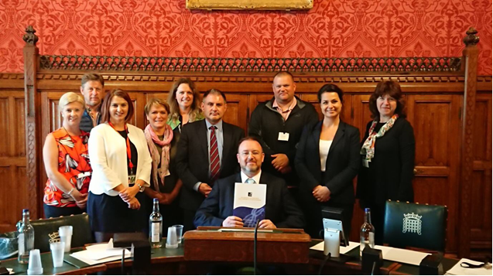
Appendix 1
All-Party Parliamentary Group for 22q11 Syndrome
Briefing Document for members of the APPG from Jack Lopresti MP
Why?
- A constituent’s daughter suffers from this syndrome and it has resulted in her having Learning Difficulties. The parents would like the syndrome recognised and tested for by the NHS because it will have on going effects throughout her life.
- 22q11 syndrome is estimated to effect up to 35,000 people in the UK.
- Detection rate is very low, so most people do not get the help they need.
- Max Appeal is a charity for individuals and families affected by 22q11 syndrome.

What is the Syndrome?
There are about 40 missing genes on part of the long (q) arm of the 22nd Chromosome.
Deficiency may result in:
- Palate defects
- Cardiac abnormalities from birth
- Many endocrine (gland and hormone) issues
- Immunity problems and auto-immune disorders
- Learning difficulties
- Attention deficit
- Very high prevalence of severe mental health disorders

A National Consensus Document written by a many of eminent clinicians with over 40 contributors in total, has been published by the Max Appeal. The group was chaired by Dr Rick Herriot, consultant immunologist Aberdeen Royal Infirmary, and the document was edited by Dr Jeremy Allgrove, consultant paediatric endocrinologist at Barts and The London NHS Trust.
Aims
- Max appeal is looking for the NHS to be able to compile a comprehensive and universally agreed lifelong care plan for people with 22q11 syndrome.
- The number of people suffering with the syndrome is growing because of better medical care and as this is most often not an inherited genetic syndrome it is currently not possible to predict who is affected or will have a child with the condition.
- Therefore increasingly important that once diagnosed a multi-disciplinary team approach will be required for most people with the syndrome.
- Treatment and support for people with Syndrome can be improved if a joined up approach is followed by Healthcare professionals.
- APPG will bring the 22q11 syndrome to the attention of policy makers.
Appendix 2

MPs support children with 22q11 Syndrome
All Party Parliamentary Group

On 13th September 2017 the All-party Parliamentary Group (APPG) for 22q11 syndromes was re-registered following the general election.

At this inaugural meeting David Duguid MP was elected as the Chairman of the group. David was approached by his constituent Louise Henderson to be part of the APPG as she has a child affected by the condition and feels that MPs can make a significant difference for those with 22q11DS.

David says:
“I am delighted and honoured to accept the role of Chairman of the All Party Parliamentary Group (APPG) for 22q11 Syndrome. I am grateful to Jack Lopresti MP for the work that he and group have done in recent years and I look forward to working with them on increasing awareness of this condition and, in particular, to help reduce the occurrence of mis-diagnosis. I have already had the pleasure of meeting some of the team from around the UK that have been involved in Max Appeal and look forward to working with them in the coming years.”

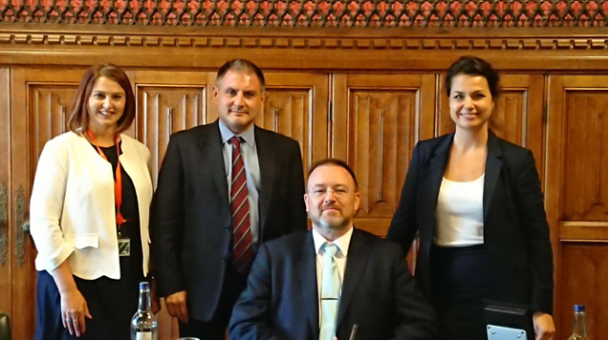
Photo: Officers of the 22q11 syndromes APPG; David Duguid – Chairman, with Heidi Allen – Secretary, Jack Lopresti – Vice Chair and Melanie Onn – Vice Chair

Jack Lopresti MP chaired the APPG for Max Appeal and other stakeholders for 3 years. The charity supports those affected by 22q11 Syndrome - a complex condition that is often undiagnosed and leads to lifelong struggles for those affected. Jack set up the APPG to raise awareness of this medical condition after meeting one of his constituents who has a daughter with the condition.

Jack says:
“It has been a privilege to chair the All Party Parliamentary Group for 22q11 Syndrome since its inception in 2014 and helping to raise awareness of this condition among my fellow MP's and bringing it to the attention of Government ministers. I am especially proud of the APPGs report that was produced in 2016 and is now being used to teach medical students across the country, a move that I hope will dramatically improve the diagnosis of 22q11 Syndrome and help patient treatment. I am sure that the APPG will continue to reach new milestones under the chairmanship of David Duguid MP and I will continue to offer my full support to improve the lives of those living with this condition.”

These conditions affect health and quality of life from birth through infancy and childhood into adult life with over 180 physical, functional and psychological associations reported. The complexity of 22q11 frequently leads to clinical confusion and a delay in diagnosis often by years.
At the 2016 AGM of the APPG, a report (referred to in Jack’s statement and being held by David Duguid in the photo), on the progress made by the group titled “Landscape for People with 22q11 syndromes in the UK” was submitted to MPs. The report paints a fairly bleak picture in terms of under-diagnosis of the condition and access to appropriate care. A copy is available from info@maxappeal..org.uk and is attached to this email.

Dr Alex Habel, former Great Ormond Street Paediatrician and world expert on 22q11 syndromes, says:
“It is the key to improving these individual’s lives by early and anticipatory delivery of care. From conception onwards it affects many body systems, including the heart, palate, immune system, behaviours and mental health. Care is therefore best provided by a multidisciplinary team throughout the life cycle. Education about early recognition of 22q11 syndrome should extend to all professional disciplines who specialise in delivery of health and psychological services, and education, to children”.

Julie Wootton, chair of trustees, Max Appeal, says:
“We are delighted to be able to register this APPG so that it can build upon the success of the last 3 years. We are incredibly grateful to David Duguid, Jack Lopresti and the other MP’s putting their weight behind it. We hope that this will continue to raise both awareness and understanding of the needs of these families, their children and adults living with the condition.”

- Ends -

Further information:
www.maxappeal.co.uk tel: 0300 999 2211

Notes to Editors
- Case studies are available for interview, please call the numbers above to make arrangements.
- Max Appeal is a small national charity, run almost exclusively by a group of dedicated volunteers backed up with a knowledgeable panel of medical professionals. The charity was inspired by Max who sadly had a short life. Today, Max Appeal is a charity with a vibrant life of its own. The charity’s mission is to ensure that every person with 22q11.2 DS lives an independent and prosperous a life as possible

